**LEAD CASE STUDY – Assignment Subjective Questions and Answer:**

1. **Which are the top three variables in your model which contribute most towards the probability of a lead getting converted**

Ans: **T**he top three variables in your model which contribute most towards the probability of a lead getting converted are:

* 1. **What is your current occupation. [ positively co-relation]**
  2. **Tags. [Both negatively and positively co-related]**
  3. **Lead Source. [Both negatively and positively co-related]**

**After studying the final Logistic Model logm6, I got values from comparing the co-efficient.**

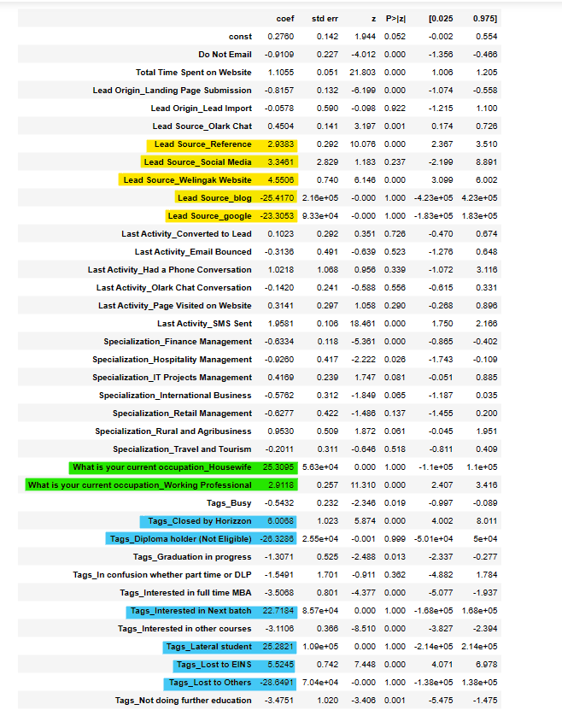

1. **What are the top 3 categorical/dummy variables in the model which should be focused the most on in order to increase the probability of lead conversion?**

Ans: The top 3 categorical/dummy variables in the model which should be focused the most on in order to increase the probability of lead conversion are:

* 1. **What is your current occupation_Housewife –** Occupation as Housewife are more likely to join the course and chances of having high probability of lead Conversion and it is

positively corelated.

* 1. **Tags - Tag_Lateral student. -** Lateral student and next coming month courses have high probability of lead Conversion and makes positive correlation.

**-Tag_Shall take in the next coming month**.

* 1. **Lead Source - Lead Source_Welingak Website –** make a positively correlation. i.e., Lead source increases then Conversion rate also increases.

**Lead Source_Social Media-** make a positively correlation

**Lead Source_google -** make a negative correlation. i.e., Lead source increases then Conversion rate may get increase or decrease.

**Lead Source_blog -** make a negative correlation

1. **X Education has a period of 2 months every year during which they hire some interns. The sales team, in particular, has around 10 interns allotted to them. So during this phase, they wish to make the lead conversion more aggressive. So they want almost all of the potential leads (i.e. the customers who have been predicted as 1 by the model) to be converted and hence, want to make phone calls to as much of such people as possible. Suggest a good strategy they should employ at this stage.**

* Ans: Target leads that spend a lot of time on X-Education site (Total Time Spent on Website) will be closely monitored by intern.
* Target leads that repeatedly visit the site (Page Views Per Visit). However, they might be repeatedly visiting to compare courses from the other sites, as the number of visits might be for that reason. So, the interns should closely pay attention to this.
* Target leads that have come through References as they have a higher probability of converting, intern should keep a check on it.
* Students can be approached, but they will have a lower probability of converting due to the course being industry based. However, this can also be a motivating factor to ensure industry readiness by the time they complete their education. Aso focus on Working Professionals going for the course to increase their skillset have high chances of joining it around 30-35% conversion rate for Unemployed and working Professional.
* Target Leads coming from Lead Origin -- API and Landing Page Submission have 40-50% conversion rate Thus intern should properly monitor them.
* Target Lead Source from Google and Direct Traffic has a very high chance of getting converted. Hence intern focuses on these platforms.
* Target Leads whose Last Activity -- SMS Sent is almost 65% Conversion Rate. Thus, intern should pay attention to this point too.
* Target Leads having Tags - 'Will revert after reading the email'. have high chances of conversion. Thus, intern should pay attention to this.

1. **Similarly, at times, the company reaches its target for a quarter before the deadline. During this time, the company wants the sales team to focus on some new work as well. So during this time, the company’s aim is to not make phone calls unless it’s extremely necessary, i.e. they want to minimize the rate of useless phone calls. Suggest a strategy they should employ at this stage.**

* Ans : Do not focus on unemployed leads. They might not have a budget to spend on the course.
* Do not focus on students, since they are already studying and would not be willing to enrol into a course specially designed for working professionals, so early in the tenure